**Minimax Algorithm in AI (Artificial Intelligence)**

**Why Minimax Search in AI Matters**

Let's understand why the Minimax algorithm is so important in the realm of artificial intelligence:

**1. Game-Playing AI:** The Min Max algorithm in AI is the backbone of game-playing AI. It's the brains behind AI opponents in board games like chess, checkers, and Go, as well as video games, where NPCs and adversaries need to make strategic decisions.

**2. Strategic Decision-Making:** Games aren't just about fun and entertainment; they serve as a microcosm of strategic decision-making in real-life situations. By mastering the Min Max algorithm in artificial intelligence, we gain insights into how AI can make optimal choices amid uncertainty and competition.

**3. Real-World Applications:** The principles behind Minimax extend beyond the gaming world. They have applications in domains like finance, military strategy, and even business decision-making, where competitive scenarios and resource allocation come into play.

**4. The Art of Balance:** Minimax embodies the art of balancing risk and reward. It's about finding the best move while considering the worst-case scenario—making it a critical tool for AI agents seeking to outmaneuver human opponents or solve complex problems.

As we journey through this session, you'll gain a deep understanding of how the Min Max algorithm in AI operates and its role in strategic decision-making. So, let's start exploring this fascinating concept and its implications in the world of AI and gaming.

**Understanding Game Trees**

**Defining Game Trees:**

A game tree is a fundamental concept in the world of game theory and artificial intelligence, particularly in the context of the Minimax algorithm in AI. It serves as a visual representation of all possible moves and outcomes in a two-player game. Game trees are essential for decision-making in games, allowing AI agents to explore potential moves and make strategic choices.

**Role of Game Trees:**

Game trees play a crucial role in representing the decision-making process in two-player games. They enable AI agents to:

1. **Evaluate Moves:** By exploring different branches of the tree, AI agents can evaluate the consequences of each possible move.
2. **Plan Strategies:** Game trees help AI agents plan strategies by considering multiple moves ahead and predicting the outcomes of different sequences of moves.

**Structure of a Game Tree:**

Let's break down the structure of a game tree, incorporating the Minimax algorithm in AI:

* **Nodes:** Nodes represent specific game states. In a two-player game, there are two types of nodes:
  + **Max Nodes:** These represent the states where it's the maximizing player's (Player Max) turn to make a move.
  + **Min Nodes:** These represent the states where it's the minimizing player's (Player Min) turn to make a move.
* **Branches (Edges):** Branches connect nodes and represent possible moves or choices. Each branch corresponds to a legal move that a player can make.
* **Terminal States:** Terminal states are the leaves of the game tree and represent game outcomes, such as a win, loss, or draw. These states have no child nodes because the game is over.

**Illustrating with Tic-Tac-Toe:**

Let's use the game of Tic-Tac-Toe as an example to illustrate the construction of a game tree, incorporating the Minimax algorithm and Minimax search procedure in artificial intelligence:

* **Starting State:** At the top of the game tree, we have the starting state of the game, where the board is empty.
* **Player Max's Turn:** Player Max (e.g., X) has several possible moves, each represented as a branch leading to a new game state.
* **Player Min's Turn:** For each of Player Max's moves, Player Min (e.g., O) has its own set of possible moves, creating a new set of branches.
* **Terminal States:** The game tree continues to expand until we reach terminal states where someone wins, there's a draw, or all possible moves have been made.

By constructing and exploring this game tree with the Minimax algorithm in AI, AI agents can assess different move sequences and select the most favorable one. The Minimax algorithm operates within this game tree, evaluating game states to make strategic decisions. As we delve further into the Minimax algorithm, you'll see how it uses game trees to find optimal moves in two-player games and the relevance of the Min max search procedure in ai.

**Two Players and Utility Functions**

**Introducing Max and Min:**

In the Minimax algorithm, we have two key players, each with distinct roles:

1. **Maximizing Player (Max):** Max is the player seeking to maximize their utility or score using the Minimax in AI strategy. In most games, Max represents the AI or the player whose turn it is to make a move. Max aims to make moves that lead to the highest possible outcome using the min max search in AI.
2. **Minimizing Player (Min):** Min is the player seeking to minimize Max's utility or score. Min represents the opponent, whether it's another player or the AI-controlled opponent. Min aims to make moves that lead to the lowest possible outcome for Max.

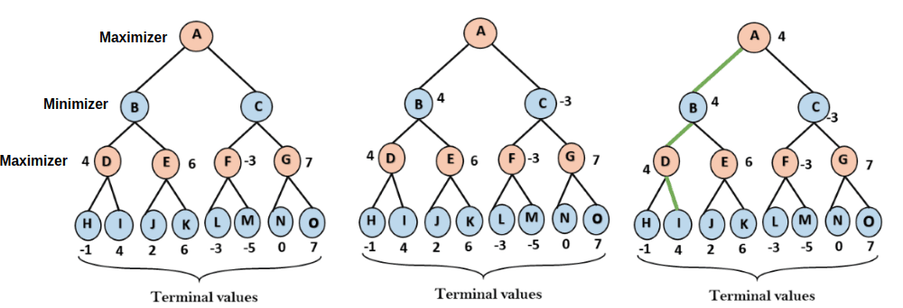

**Role of Utility Functions:**

Utility functions, also known as evaluation functions, are central to the Minimax algorithm. They serve two primary purposes:

1. **Quantifying Game States:** Utility functions assign numeric values to game states, representing how favorable or unfavorable each state is for Max in the context of the minimax algorithm in artificial intelligence.
2. **Evaluating Potential Moves:** By evaluating the utility values of different game states, Max can determine which moves lead to more advantageous positions. Max seeks to choose moves that result in game states with higher utility values using the min max search in AI.

**Determining Desirability:**

The utility function acts as a critical tool for determining the desirability of a game state. Here's how it works:

* **Higher Utility = More Desirable:** A higher utility value indicates that the game state is more favorable for Max. Max strives to maximize this value because it represents a better position or outcome.
* **Lower Utility = Less Desirable:** Conversely, a lower utility value suggests a less favorable game state for Max. Min aims to minimize this value because it represents a worse position or outcome for Max.
* **Strategic Decision-Making:** With utility values at their disposal, Max and Min can make strategic decisions. Max seeks to find the move that leads to the highest utility, while Min seeks to minimize Max's utility, often by choosing moves that lead to lower utility for Max.

**Example: Tic-Tac-Toe Utility Function:**

Let's consider a simple example using Tic-Tac-Toe:

* In Tic-Tac-Toe, Max may use a utility function that assigns a value of +1 for a winning state, -1 for a losing state, and 0 for a draw. This function quantifies the desirability of game states.
* When Max evaluates a game state where it has three X's in a row (a winning state), the utility function assigns a utility value of +1, indicating a highly desirable position.
* Conversely, when Max evaluates a game state where Min has three O's in a row (a losing state), the utility function assigns a utility value of -1, signaling a highly undesirable position, incorporating the minimax algorithm in artificial intelligence.

By leveraging utility functions and the Minimax algorithm, AI agents can make informed decisions in two-player games, strategically choosing moves that lead to more favorable outcomes while anticipating the opponent's attempts to minimize their utility. This delicate balance of decision-making is at the core of Minimax and its applications in game-playing AI.

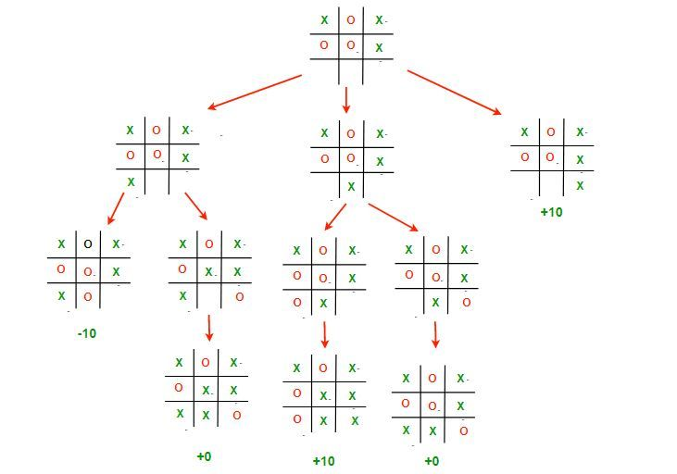

**The Minimax Algorithm in AI Example**

Now, let's delve into the core principles of the Minimax algorithm incorporating Minimax in AI. At its heart, Minimax is all about making strategic decisions in two-player games by alternating between the maximizing player (Max) and the minimizing player (Min) using the minimax algorithm in artificial intelligence. Here's an overview of how it works:

1. **Alternating Turns:** The algorithm begins with Max's turn, who explores possible moves and their outcomes. Max aims to maximize the utility (score) of the game state.
2. **Anticipating Opponent:** Max anticipates that Min will choose moves to minimize Max's utility. So, during Min's turn, Min explores the game tree, aiming to minimize Max's utility using the min max search in AI.
3. **Depth-Limited Search:** The algorithm typically operates within a limited depth of the game tree. Deeper exploration results in a more accurate evaluation but requires more computation.
4. **Utility Evaluation:** At the terminal game states (win, loss, or draw), the utility function assigns a utility value to evaluate the desirability of those states from Max's perspective.
5. **Backtracking:** As the algorithm explores the game tree, it backtracks to propagate utility values up the tree. Max nodes select moves that maximize utility, while Min nodes select moves that minimize it.

**Step-by-Step Example - Tic-Tac-Toe:**

Let's walk through a simplified example of the Minimax algorithm using a Tic-Tac-Toe game tree. In this scenario, we'll limit the depth of the tree to make it manageable. Here's our game tree:

* Starting State (Max's Turn):
  + Max chooses the center square (utility: 0).
  + Game Tree Depth: 1
* Min's Turn:
  + Min chooses a corner square (utility: 0).
  + Game Tree Depth: 2
* Max's Turn:
  + Max chooses an edge square (utility: 0).
  + Game Tree Depth: 3
* Min's Turn:
  + Min chooses a corner square (utility: 0).
  + Game Tree Depth: 4
* Terminal State: The game ends in a draw (utility: 0).

In this simplified example, the utility values are all 0 because it's a draw. However, in a real scenario, utility values would reflect the desirability of different outcomes, such as +1 for a win, -1 for a loss, and 0 for a draw.

**Depth and Algorithm Complexity:**

The depth of the game tree significantly impacts the algorithm's complexity. A deeper search allows for more accurate evaluations but increases computational demands. Here's how depth influences the algorithm:

* **Shallow Depth:** Shallow searches (few moves ahead) make the algorithm faster but may lead to suboptimal decisions because it doesn't consider long-term consequences.
* **Deep Depth:** Deeper searches (many moves ahead) yield more precise evaluations but require more time and resources. This is suitable for games where long-term planning is essential.
* **Optimization:** To manage complexity, Minimax is often combined with techniques like Alpha-Beta pruning, which reduces the number of explored nodes by eliminating branches that won't affect the final decision using the Min Max algorithm in artificial intelligence.

By mastering the Minimax algorithm's core principles and understanding the trade-offs related to depth, AI agents can make strategic decisions in various two-player games, ranging from chess to complex board games, with the goal of outsmarting opponents and maximizing their chances of success.

**Limitations and Enhancements**

**Limitations of the Basic Minimax Algorithm:**

While the Minimax algorithm is a powerful tool for game-playing AI, it does have some limitations that can affect its performance:

1. **Exponential Growth:** One of the most significant limitations is the exponential growth of the game tree. As the depth of the tree increases, the number of possible states and nodes to evaluate grows exponentially. This can make Min max in AI impractical for deep searches in complex games.
2. **Complete Knowledge:** Minimax assumes that both players have complete knowledge of the game state and can perfectly predict their opponent's moves. In reality, games with imperfect information or uncertainty pose challenges for Minimax.
3. **Deterministic Games:** Minimax is most suitable for deterministic games, where the outcome of each move is certain. In games with randomness or hidden information, additional techniques are needed.

**Enhancements and Optimizations:**

To address the limitations of the basic Minimax algorithm and make game-playing AI more efficient, several enhancements and optimizations have been developed:

1. **Alpha-Beta Pruning:** Alpha-Beta pruning is a powerful optimization technique that reduces the number of nodes evaluated in the game tree. It eliminates branches that cannot affect the final decision because they lead to worse outcomes. Alpha-Beta pruning significantly improves the algorithm's efficiency.
2. **Iterative Deepening:** To balance the trade-off between accuracy and computation time, iterative deepening is used. It involves performing a series of depth-limited Minimax searches, gradually increasing the depth. This ensures that the algorithm explores deeper as time allows.
3. **Heuristics:** In some cases, instead of searching the entire game tree, AI agents use heuristics or evaluation functions to estimate the desirability of game states. This is common in games with extensive branching factors, like chess. While heuristics may not guarantee optimal results, they reduce computation time.
4. **Monte Carlo Tree Search (MCTS):** MCTS is a modern enhancement for game-playing AI, particularly effective in games with a high branching factor. It combines random simulations with tree exploration to identify promising moves. MCTS has been successful in games like Go and has revolutionized AI game-playing.
5. **Parallelization:** Utilizing parallel processing can speed up the Minimax algorithm, especially in multi-core systems. This allows simultaneous exploration of different branches of the game tree.
6. **Deep Learning:** In some cases, deep learning techniques are used to improve the evaluation function. Neural networks can learn patterns and strategies from extensive training data, enhancing AI performance.

These enhancements and optimizations address the practical challenges faced by Minimax in complex games, making it more feasible for AI agents to excel in games like chess, Go, and real-time strategy games. While the basic Min Max in AI algorithm lays the foundation, these techniques make AI-driven game-playing more competitive and enjoyable.

**Real-World Applications of the Minimax Algorithm in Game-Playing AI**

The Minimax algorithm, and its enhancements, has found extensive use in various real-world applications of game-playing AI. Here are some notable examples:

1. **Chess:** The Minimax algorithm is a fundamental component of chess-playing AI systems. Grandmaster-level chess programs like IBM's Deep Blue and more recent engines like Stockfish use variations of Minimax to search for optimal moves, predict opponent responses, and evaluate board positions. Chess AI has reached a level where it can outperform human world champions.
2. **Checkers (Draughts):** Similar to chess, checkers AI systems employ Minimax-based algorithms to play the game at a high level. Chinook, an AI developed by researchers at the University of Alberta, is an example of a checkers AI that uses Minimax and endgame databases to play checkers at a world-class level.
3. **Video Games:** The Minimax algorithm is applied in video games to create challenging AI opponents. In strategic and turn-based games like Civilization and XCOM, Minimax helps computer-controlled players make intelligent decisions. In real-time strategy games like StarCraft, Minimax-based AI is used to manage unit behavior and make tactical choices.
4. **Board Games:** Beyond chess and checkers, Minimax is employed in a wide range of board games, including Go, Othello, and Connect Four. These games often have well-defined rules and deterministic outcomes, making them suitable for Minimax-based AI.

**Advanced Variations: AlphaGo and Beyond:**

While the basic Minimax algorithm laid the foundation for game-playing AI, advanced variations and techniques have pushed the boundaries of what AI can achieve:

1. **AlphaGo:** AlphaGo, developed by DeepMind, achieved historic success in the game of Go. Instead of pure Minimax, AlphaGo uses a combination of techniques, including Monte Carlo Tree Search (MCTS) and deep neural networks. This approach enabled AlphaGo to defeat human world champion Go players, demonstrating the power of AI in mastering complex games.
2. **AlphaZero:** Building upon the success of AlphaGo, AlphaZero is a more generalized AI system capable of mastering multiple board games, including chess and shogi. It combines deep neural networks with Monte Carlo Tree Search and reinforcement learning, eliminating the need for human-designed heuristics.
3. **Reinforcement Learning:** In video games and real-world scenarios, reinforcement learning techniques, which are inspired by Minimax principles, are used to train AI agents to make decisions and optimize rewards. These agents can adapt to dynamic and uncertain environments.
4. **Real-Time Strategy Games:** In real-time strategy games like Dota 2 and StarCraft II, AI agents rely on a combination of rule-based systems, heuristics, and search algorithms to make real-time decisions. While not strictly Minimax-based, these AI systems aim to maximize their chances of winning.

In summary, the Minimax algorithm and its variations have a profound impact on game-playing AI across a wide spectrum of games. From traditional board games to modern video games and even complex strategy games like Go, AI agents continue to challenge and surpass human players, showcasing the remarkable advancements in artificial intelligence.

**Conclusion**

In conclusion, the Minimax algorithm stands as a foundational concept in the realm of game-playing artificial intelligence. It embodies the strategic essence of decision-making in two-player games, where each player strives to outmaneuver the other.

**Key Takeaways**

* **Minimax Basics:** The Minimax algorithm is centered on two players, Max and Min, who alternate turns to maximize their utility or minimize their opponent's utility.
* **Game Trees:** Game trees visually represent all possible moves and outcomes in games, serving as the foundation for the Minimax algorithm.
* **Utility Functions:** Utility functions assign values to game states, allowing AI agents to assess the desirability of different outcomes.
* **Depth and Complexity:** The depth of the game tree significantly impacts the algorithm's complexity. Balancing depth and computation time is crucial for practical implementations.
* **Limitations:** Minimax has limitations, including exponential growth in complex games and the assumption of complete knowledge.
* **Enhancements:** Enhancements like Alpha-Beta pruning, Monte Carlo Tree Search (MCTS), and heuristics mitigate Minimax's limitations and improve efficiency.
* **Real-World Applications:** Minimax and its variations are used extensively in real-world applications, from chess and checkers to video games and board games.
* **AlphaGo's Triumph:** AlphaGo, an advanced AI system, demonstrated the power of AI in mastering complex games by defeating human Go champions.
* **Ongoing Advancements:** AI in game-playing continues to advance, leveraging deep learning, reinforcement learning, and real-time strategy techniques to achieve remarkable results.

The Minimax algorithm represents not just a mathematical concept but a testament to the ingenuity of human-created intelligence. It challenges us to think strategically, optimize outcomes, and explore the uncharted territory of AI in games and beyond.